Google Analytic like Backend System – High Level Architecture

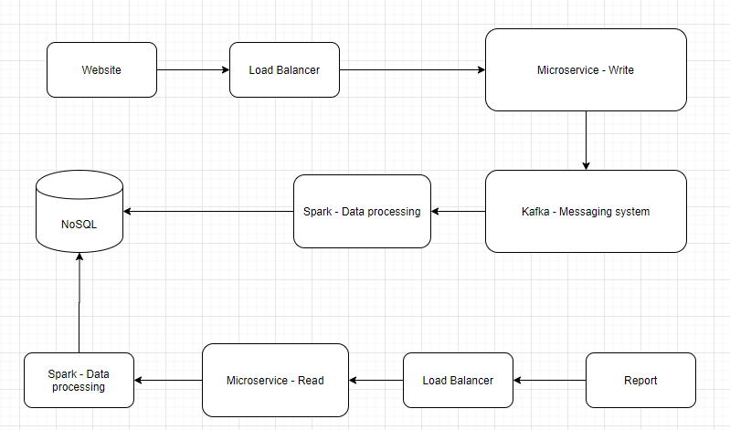

**Load Balancer** – we can use Nginx cluster for the load balancer. Load balancing across multiple application instances is a commonly used technique for optimizing resource utilization, maximizing throughput, reducing latency, and ensuring fault‑tolerant configurations.

**Microservice** – Using Nacos cluster and Sentinel for dynamic service discovery and configuration and service management.

**NoSQL** – We can use MongoDB replication to ensure all the write queries go to the main node, and all the read queries go to sub-nodes.

**Kafka** – Used for internal communication between different components. Always, it can ensure there is not too much write queries go to database directly.

**Spark** – Spark in-memory computing, which provides a faster and more general data processing platform.